**Lab manual 9!**

**Functions(Pass by value)**

**Task 1**:

Write a C++ program to calculate the following expression using sum and sub functions and displays its value. y=sum(a,b)+sub(a,b).

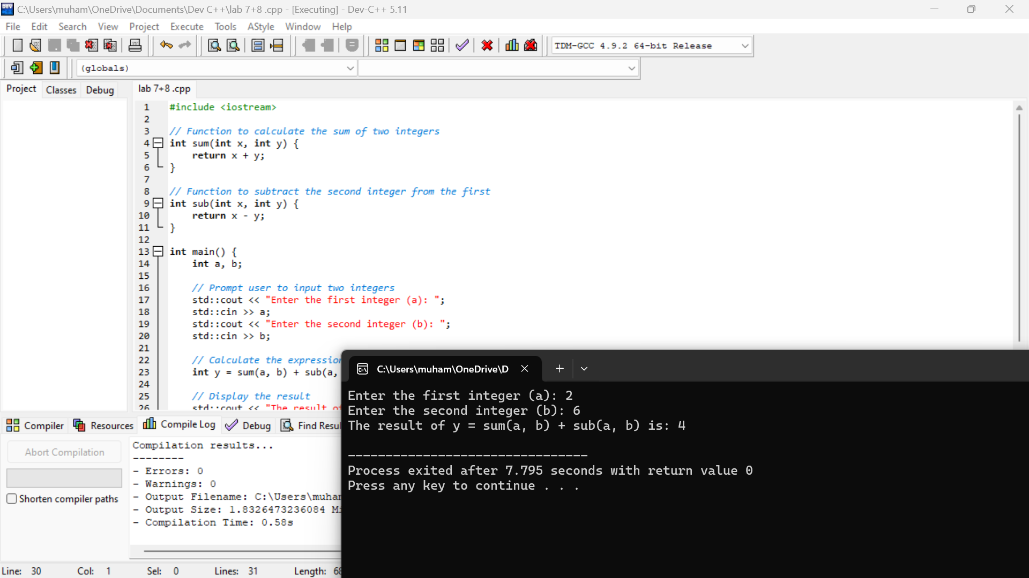

**Task 2**:

Write a C++ program to create menu driven calculator that performs basic arithmetic operations (add, subtract, multiply and divide) using functions & switch case.

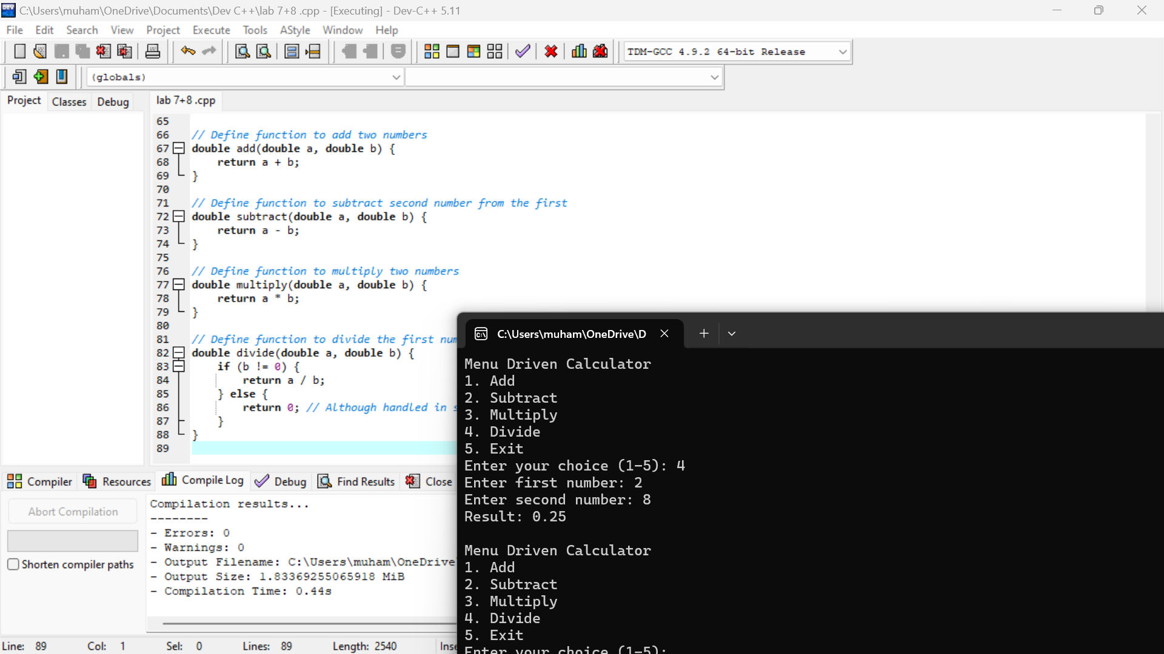

**Task 3:**

Write a C++ program that prompts the user to enter two integers and displays their greatest common divisor using functions. Note: The greatest common divisor (gcd) of two or more integers, which are not all zero, is the largest positive integer that divides each of the integers. For example, the gcd of 8 and 12 is 4.

